./



Version Number:

Team Members :

Team No:

Module: Model Based System Engineering

|  |  |  |  |  |  |
| --- | --- | --- | --- | --- | --- |
| **Ver.Rel. No.** | **Release Date** | **Prepared. By** | **Reviewed By** | **Approved By** | **Remarks/Revision Details** |
|  |  |  |  |  |  |
|  |  |  |  |  |  |
|  |  |  |  |  |  |
|  |  |  |  |  |  |
|  |  |  |  |  |  |

**Document History**

# 

**OBSTACLE DETECTING ROBOT**

**Introduction:**

* This is a robot which detects the object and moves accordingly
* We can use this without remote and it automatically detects the obstacle because it is integrated with infrared sensor.

**BLOCK DIAGRAM:**

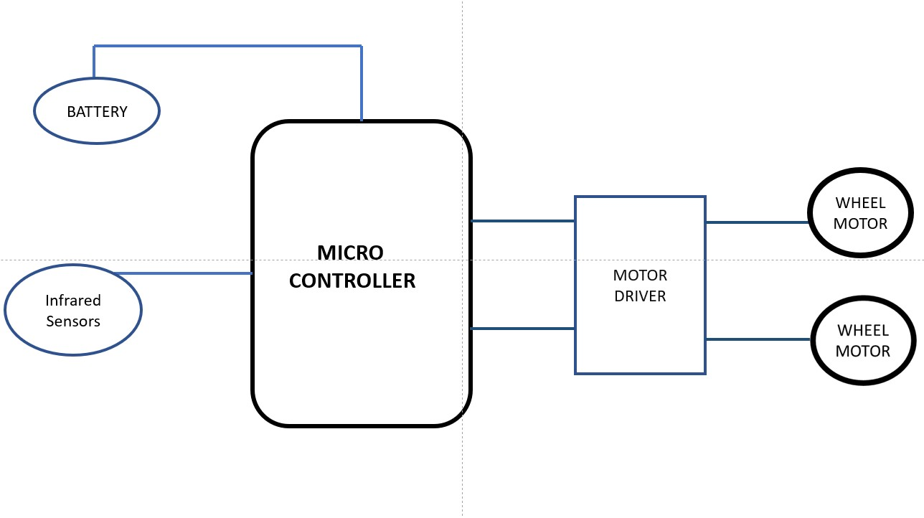

**Components used:**

1 Battery

2 Infrared Sensor (transmitter and receiver)

3 Microcontroller

4 Motor wheels

5 Motor driver (L293D)

**WORKING PRINCIPLE:**

* Infrared rays will be emitted through IR transmitter (IR LED)
* If there is any obstacle the rays get reflected and receives to IR receiver (Photo diode).
* Hence it will move to right or left.
* The movement of the robot done by motor driver.
* Two wheels are dedicated with two motors for movement.
* Two motors have P (+ve) and N (-ve ) terminals and coded accordingly for motion.
* 10 – clockwise rotation of wheel
* 01 –Anti clockwise rotation of wheel

MOTION FOLLOWS AS:

|  |  |  |  |  |
| --- | --- | --- | --- | --- |
| LEFT MOTOR |  | RIGHT MOTOR |  | MOTION |
| P | N | P | N |  |
| 1 | 0 | 1 | 0 | Forward |
| 0 | 1 | 0 | 1 | Backward |
| 1 | 0 | 0 | 1 | Right |
| 1 | 0 | 1 | 0 | Left |

Low level requirements:

1 Input from the three infrared sensors.

High level requirement:

1 Microcontroller

2 Motor wheels

3 Motor driver (L293D)

4 Battery